1-GSM

📶 What Is GSM?
# Source: Chatgpt (GPT-5-Mini) at [1/23/2026]
GSM stands for Global System for Mobile Communications.
It is a 2G (second-generation) standard for mobile networks used to enable voice calls, SMS, and basic mobile data services.
🧠 GSM was the first digital mobile network standard used worldwide — and it's still widely used for calls and SMS today.

📜 Originally:
# Source: Chatgpt (GPT-5-Mini) at [1/23/2026]
- Developed in Europe in the 1980s
- Became the global standard for mobile communication
- Replaced analog systems like 1G (e.g., AMPS)

📲 Key Features of GSM:
# Source: Chatgpt (GPT-5-Mini) at [1/23/2026]
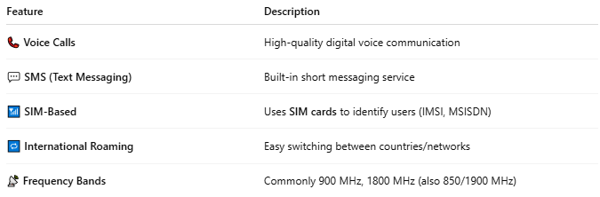

Feature | Description
📞 Voice Calls | High-quality digital voice communication
💬 SMS (Text Messaging) | Built-in short messaging service
📶 SIM-Based | Uses SIM cards to identify users (IMSI, MSISDN)
🔁 International Roaming | Easy switching between countries/networks
📡 Frequency Bands | Commonly 900 MHz, 1800 MHz (also 850/1900 MHz)

🛠️ Technical Components of GSM:
# Source: Chatgpt (GPT-5-Mini) at [1/23/2026]
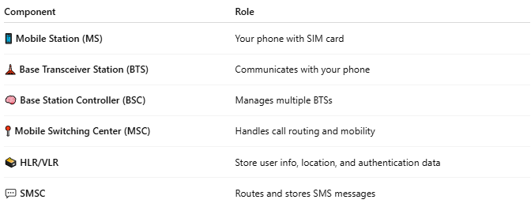

Component | Role
📱 Mobile Station (MS) | Your phone with SIM card
🗼 Base Transceiver Station (BTS) | Communicates with your phone
🧠 Base Station Controller (BSC) | Manages multiple BTSs
📍 Mobile Switching Center (MSC) | Handles call routing and mobility
🗃️ HLR/VLR | Store user info, location, and authentication data
💬 SMSC | Routes and stores SMS messages

🔐 Security in GSM:
# Source: Chatgpt (GPT-5-Mini) at [1/23/2026]
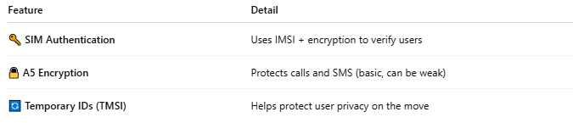

Feature | Detail
🔑 SIM Authentication | Uses IMSI + encryption to verify users
🔒 A5 Encryption | Protects calls and SMS (basic, can be weak)
🔄 Temporary IDs (TMSI) | Helps protect user privacy on the move

🌍 Global Adoption:
# Source: Chatgpt (GPT-5-Mini) at [1/23/2026]
- Used in over 200 countries
- GSM is the base for UMTS (3G), LTE (4G), and 5G
- Devices that support GSM often work across multiple carriers

🆚 GSM vs Other Technologies:
# Source: Chatgpt (GPT-5-Mini) at [1/23/2026]
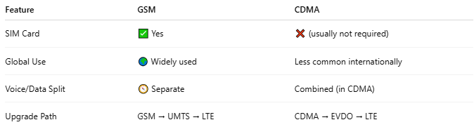

Feature | GSM | CDMA
SIM Card | ✅ Yes | ❌ (usually not required)
Global Use | 🌍 Widely used | Less common internationally
Voice/Data Split | 🧭 Separate | Combined (in CDMA)
Upgrade Path | GSM → UMTS → LTE | CDMA → EVDO → LTE

📖 Summary:
# Source: Chatgpt (GPT-5-Mini) at [1/23/2026]
GSM is:
- 🌐 A global 2G mobile communication standard
- 📞 Enables voice, SMS, and SIM-based identification
- 🧱 The foundation for modern mobile technologies
- 💡 Still used today for basic services, especially in IoT, M2M, and rural areas

2-GSM Modems

📲 What Is a GSM Modem?
# Source: Chatgpt (GPT-5-Mini) at [1/23/2026]
A GSM modem is a hardware device that allows a computer or other system to send and receive SMS, make voice calls, or connect to the mobile network for data, using the GSM (Global System for Mobile Communications) standard.
🧠 It acts like a mobile phone without a screen, controlled by software through a serial or USB connection.

🛠️ How It Works:
# Source: Chatgpt (GPT-5-Mini) at [1/23/2026]
A GSM modem contains:
- A SIM card (just like a phone)
- A radio module that connects to the mobile network
- A communication interface (USB, RS232, Bluetooth)
You can control it using AT commands (text commands that tell the modem what to do).

📦 Common Uses:
# Source: Chatgpt (GPT-5-Mini) at [1/23/2026]
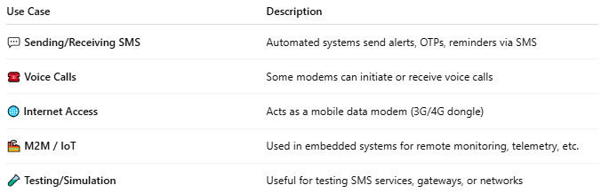

Use Case | Description
💬 Sending/Receiving SMS | Automated systems send alerts, OTPs, reminders via SMS
☎️ Voice Calls | Some modems can initiate or receive voice calls
🌐 Internet Access | Acts as a mobile data modem (3G/4G dongle)
🏭 M2M / IoT | Used in embedded systems for remote monitoring, telemetry, etc.
🧪 Testing/Simulation | Useful for testing SMS services, gateways, or networks

🔗 Connection Types:
# Source: Chatgpt (GPT-5-Mini) at [1/23/2026]
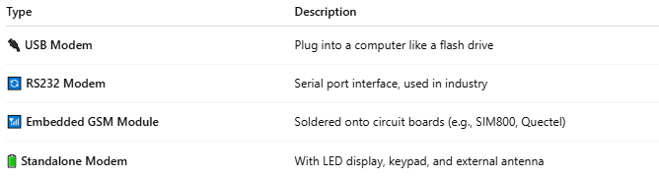

Type | Description
🔌 USB Modem | Plug into a computer like a flash drive
🔄 RS232 Modem | Serial port interface, used in industry
📶 Embedded GSM Module | Soldered onto circuit boards (e.g., SIM800, Quectel)
🔋 Standalone Modem | With LED display, keypad, and external antenna

💬 Sending an SMS with AT Commands (Example):
# Source: Chatgpt (GPT-5-Mini) at [1/23/2026]
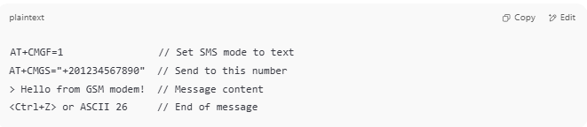

AT+CMGF=1 // Set SMS mode to text
AT+CMGS="+201234567890" // Send to this number
> Hello from GSM modem! // Message content
<Ctrl+Z> or ASCII 26 // End of message

🆚 GSM Modem vs GSM Module:
# Source: Chatgpt (GPT-5-Mini) at [1/23/2026]
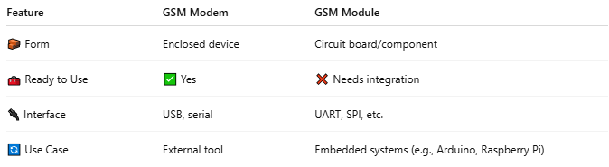

Feature | GSM Modem | GSM Module
🧱 Form | Enclosed device | Circuit board/component
🧰 Ready to Use | ✅ Yes | ❌ Needs integration
🔌 Interface | USB, serial | UART, SPI, etc.
🔄 Use Case | External tool | Embedded systems (e.g., Arduino, Raspberry Pi)

✅ Advantages:
# Source: Chatgpt (GPT-5-Mini) at [1/23/2026]
- 📤 Easy SMS integration with software
- 🧪 Great for development and testing
- 🔌 Plug-and-play (USB versions)
- 📱 Uses real SIM cards, connects to live networks

⚠️ Limitations:
# Source: Chatgpt (GPT-5-Mini) at [1/23/2026]
- 📶 Limited data speed (2G/3G for older modems)
- 💤 Not ideal for very high message volume (use gateways for that)
- 📦 Physical hardware dependency

📖 Summary:
# Source: Chatgpt (GPT-5-Mini) at [1/23/2026]
A GSM modem is:
- 📡 A device that connects to GSM networks using a SIM card
- 🧰 Used for sending SMS, voice calls, and mobile data
- 🖥️ Controlled via AT commands through a computer
- 💡 Common in IoT, automation, alerting, and SMS systems

3-GSM Modules

📦 What Is a GSM Module?
# Source: Chatgpt (GPT-5-Mini) at [1/23/2026]
A GSM module is a small electronic component (or circuit board) that allows embedded systems, microcontrollers, or computers to connect to GSM networks for sending/receiving SMS, voice calls, or mobile data.
🧠 Think of it as the core mobile part of a phone, used in IoT devices, tracking systems, remote controls, and more.

🔌 How It Works:
# Source: Chatgpt (GPT-5-Mini) at [1/23/2026]
A GSM module:
- Contains a GSM radio chip (e.g., SIM800, SIM900, Quectel, etc.)
- Has a slot for a SIM card
- Communicates with microcontrollers (like Arduino, Raspberry Pi) using serial (UART) or other interfaces
- Responds to AT commands to send SMS, make calls, or connect to the internet

📲 What Can a GSM Module Do?
# Source: Chatgpt (GPT-5-Mini) at [1/23/2026]
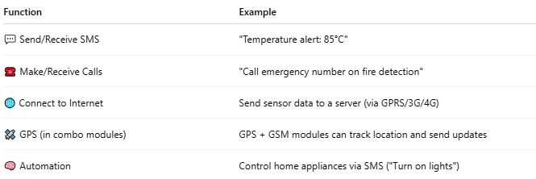

Function | Example
💬 Send/Receive SMS | "Temperature alert: 85°C"
☎️ Make/Receive Calls | "Call emergency number on fire detection"
🌐 Connect to Internet | Send sensor data to a server (via GPRS/3G/4G)
🛰️ GPS (in combo modules) | GPS + GSM modules can track location and send updates
🧠 Automation | Control home appliances via SMS ("Turn on lights")

🧩 Common GSM Modules:
# Source: Chatgpt (GPT-5-Mini) at [1/23/2026]
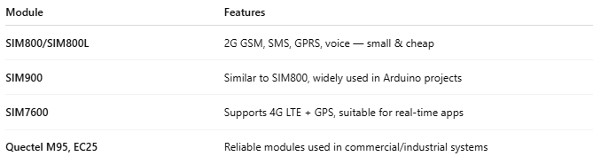

Module | Features
SIM800/SIM800L | 2G GSM, SMS, GPRS, voice — small & cheap
SIM900 | Similar to SIM800, widely used in Arduino projects
SIM7600 | Supports 4G LTE + GPS, suitable for real-time apps
Quectel M95, EC25 | Reliable modules used in commercial/industrial systems

🛠️ Example Setup with Arduino:
# Source: Chatgpt (GPT-5-Mini) at [1/23/2026]
Wiring:
- GSM TX → Arduino RX
- GSM RX → Arduino TX
- Power via 3.7–4.2V battery (⚠️ GSM modules need stable power!)
Basic AT Commands:
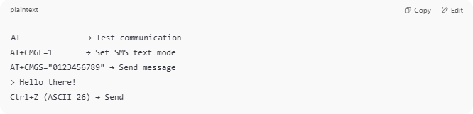
AT → Test communication
AT+CMGF=1 → Set SMS text mode
AT+CMGS="0123456789" → Send message
> Hello there!
Ctrl+Z (ASCII 26) → Send

🧰 GSM Module vs GSM Modem:
# Source: Chatgpt (GPT-5-Mini) at [1/23/2026]
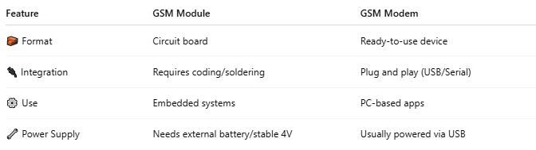

Feature | GSM Module | GSM Modem
🧱 Format | Circuit board | Ready-to-use device
🔌 Integration | Requires coding/soldering | Plug and play (USB/Serial)
⚙️ Use | Embedded systems | PC-based apps
🔧 Power Supply | Needs external battery/stable 4V | Usually powered via USB

🔐 Security & SIM:
# Source: Chatgpt (GPT-5-Mini) at [1/23/2026]
- Works with standard SIM cards
- Supports PIN protection, encryption (basic), and IMEI-based authentication

✅ Ideal For:
# Source: Chatgpt (GPT-5-Mini) at [1/23/2026]
- 🏠 Home automation
- 🛰️ GPS vehicle tracking
- 🏭 Industrial sensor reporting
- 📦 IoT and M2M (machine-to-machine) applications
- 📲 Low-cost SMS alert systems

📖 Summary:
# Source: Chatgpt (GPT-5-Mini) at [1/23/2026]
A GSM module is:
- 🧩 A hardware component that enables GSM functionality in devices
- 🛠️ Used in embedded electronics, IoT, and custom projects
- 📲 Capable of SMS, voice, and data communication
- 🧠 Controlled via AT commands from microcontrollers

